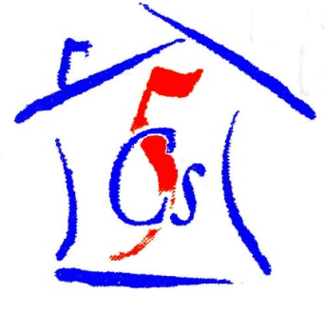

***C****hernobyl* ***C****hildren* ***C****ancer* ***C****are* ***C****ardiff*

53 Heol Llanishen Fach Rhiwbina Cardiff CF14 6LB

Tel: +44 (0)29 20624730

www.five-cs.org info@five-cs.org

Registered Charity Number: 1077451

**The first task we undertook as we took over was to establish our new team with a membership panel and changes to the trustees. We are pleased to welcome Dafydd Gape, Laura Phelan and Lynda Powell as new trustees. Our membership panel to date consists of 40 past volunteers and friends of the charity. We are really grateful for everyone’s hard work and have been overwhelmed with their support.**

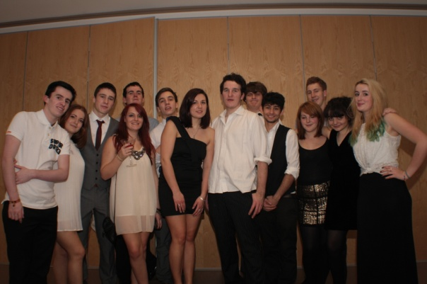

**The first fundraiser we organised as a new team was a cocktail party in December. It was a massive success with everyone enjoying themselves, members and guests alike, with a huge profit of £900. We were so pleased with our first fundraising success and we will definitely be doing it again in the years to come!**

**The planning for this summer’s volunteering program started with an open afternoon in January leading to the start of the organisation process. We will be sending a total of 28 volunteers to the Belarusian Children’s Hospice Summer Camp this summer consisting of past and new volunteers. We hope that the summer will be as much of a success as the previous years and that the volunteers both enjoy and value the experience.**

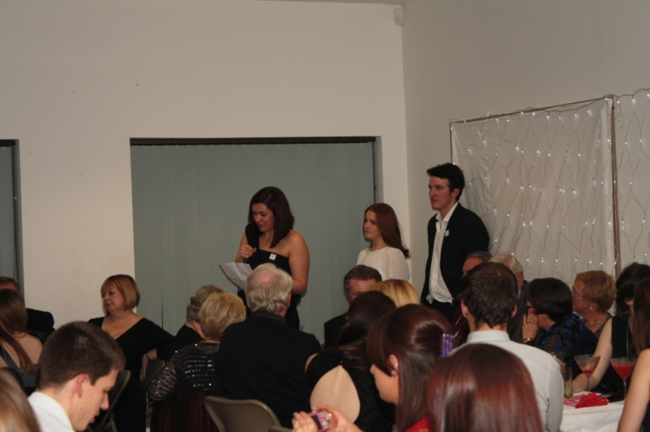

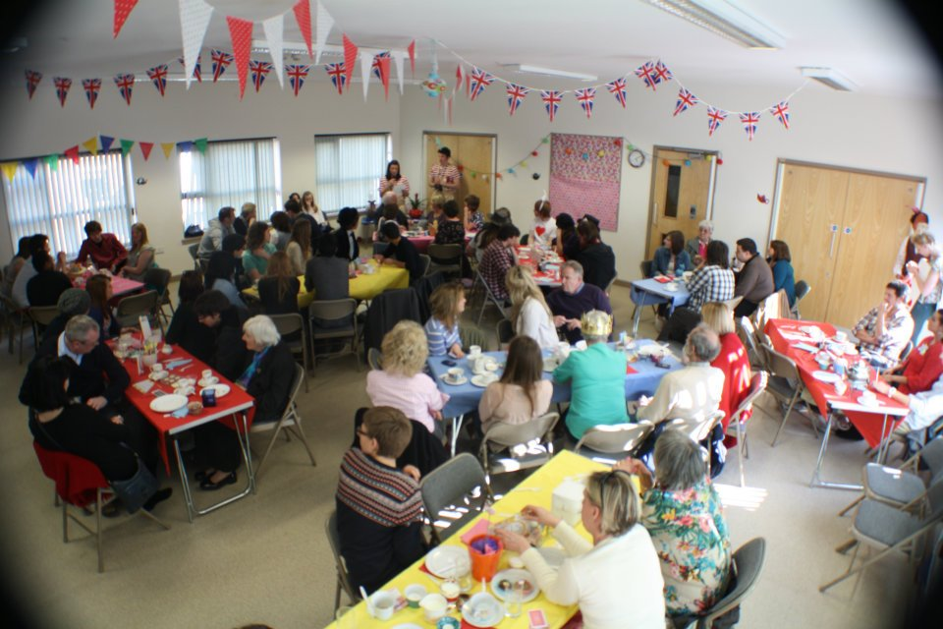

**For our second fundraiser of the year we decided to be as mad as a hatter and throw an Alice in Wonderland themed Tea Party. Once again we were overwhelmed with the success and not only did our members enter the spirit by dressing up as the characters but over 100 people came and helped us to make a massive profit of over £800!**

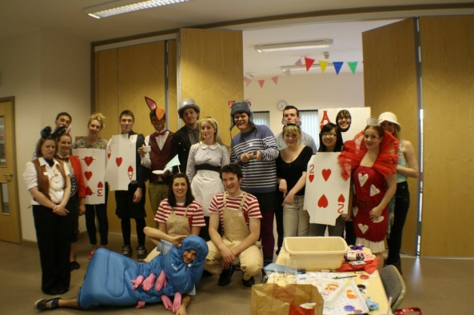

**We have just returned from a short trip to the Belarusian Children’s Hospice, delivering over $5000 to open and maintain the Summer Camp this year thanks to everybody’s fundraising efforts. While there we delivered the necessary materials for our summer in the Summer Camp, including paint and food. We also discussed the planning for the summer with the staff at the Hospice and we are now all set to go!**

**Please see our website at** [**www.five-cs.org**](http://www.five-cs.org) **or our Facebook page (search Chernobyl Children Cancer Care Cardiff) for more detailed and up to date information, photos and contact information.**

**We are so grateful for all the support everyone has shown so far and we look forward to a successful future!**

***Beth and Zac.***